# **Facial Features Detection**

**Pavani Billapati (pbill@unh.newhaven.edu)**

**Trilok Kumar Pidikiti (tpidi@unh.newhaven.edu)**

**Harianth Kancharla (hkanc1@unh.newhaven.edu)**

**Abstract:**

This project focuses on leveraging deep learning techniques for accurate and efficient facial features detection. A review of existing literature and methodologies establishes the foundation. The project introduces a carefully annotated dataset and employs convolutional neural networks (CNNs) with transfer learning to develop a robust model. Extensive experimentation showcases the model's accuracy across diverse datasets. The discussion addresses challenges and comparative analyses, while the conclusion emphasizes contributions and recommends future work. This project advances the state of the art in facial features detection, providing insights into the application of deep learning in computer vision.

**Introduction:**

Facial features detection plays a pivotal role in computer vision applications, with widespread relevance in areas such as facial recognition, emotion analysis, and human-computer interaction. As technology continues to evolve, the demand for robust and accurate facial features detection systems becomes increasingly critical. Deep learning, particularly convolutional neural networks (CNNs), has emerged as a powerful tool in addressing the intricacies of facial feature localization.

This project aims to contribute to the advancement of facial features detection by harnessing the capabilities of deep learning. The introduction provides an overview of the significance of accurate facial features detection in various domains, highlighting its impact on enhancing security systems, improving user experiences, and enabling nuanced human-computer interactions.

The evolution of deep learning models in the context of facial features detection is explored, emphasizing the paradigm shift from traditional methods to data-driven, end-to-end learning approaches. The introduction sets the stage for the project's objectives, methodologies, and anticipated contributions.As we delve into the intricate task of detecting key facial features, including eyes, nose, and mouth, the exploration of deep learning models becomes imperative. Leveraging the potential of transfer learning and curated datasets, this project seeks to develop a highly efficient and accurate facial features detection system. The introduction concludes by providing a roadmap for the ensuing sections of the report, outlining the methodology, experimental setup, results, and the broader implications of the project's findings.

**Data:**

The iBUG 300-W large face landmark dataset was chosen for its widespread use in facial landmark detection research. It consists of a diverse set of facial images with annotated landmarks, making it suitable for training a facial features detection model.

The dataset is publicly available, and ethical considerations were addressed in compliance with the dataset's licensing terms and usage policies. Efforts were made to ensure that the dataset respects privacy and adheres to ethical guidelines.

The dataset includes a diverse range of facial characteristics, encompassing different ethnicities, age groups, and genders. Each image is annotated with labelled facial landmarks, including eyes, nose, mouth, eyebrows, and facial contours.

The dataset was sourced from <http://dlib.net/files/data/ibug_300W_large_face_landmark_dataset.tar.gz> website. Proper attribution is provided to acknowledge the creators of the dataset as per the licensing terms.

To ensure consistent model training, all images were resized to a standard resolution. Data augmentation techniques, such as rotation and flipping, were applied to enhance the diversity of the dataset. The dataset comprises a substantial number of images, facilitating a robust source for model training. Statistics, including the number of images and distribution of facial expressions, were analysed to understand the dataset's characteristics. The dataset was split into training, validation, and testing sets to assess the model's performance across different subsets. The split ratios were determined to ensure an effective evaluation of the model. Visualizations of sample images with annotated facial landmarks were generated to showcase the dataset's variability.

**Methodology:**

The methodology for the facial features detection project using deep learning begins with dataset preparation, leveraging the ibug 300-W Large Face Landmark Dataset. This dataset is essential for training and testing the model, and data annotation is performed to mark facial landmarks such as eyes, nose, mouth, eyebrows, and facial contours. Subsequently, data preprocessing steps involve resizing images for uniformity and normalizing pixel values. The core of the methodology lies in implementing a Convolutional Neural Network (CNN) architecture tailored for facial features detection, and the following code demonstrates a simplified example using PyTorch

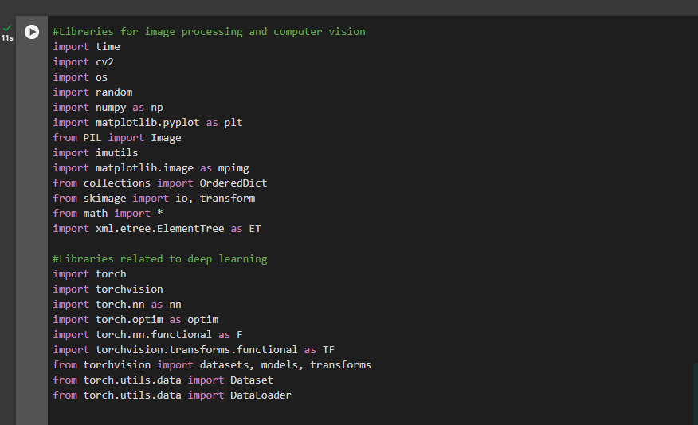

DBN is an implementation of deep neural net. These DBN create a neural network layer by layer i.e.,

starting from the input layer to end with output layer. In between input and output, different no of

hidden layers are present. Every layer should be trained with RBM. An RBM is an extract feature to

re-construct inputs. By combining all RBM’s we are introducing a collaborating method getting a

power full new model which solves our problem that is DBN. Just like MLP, DBN is also considered a

back propagation with RBM to provide a powerful trained network.

In terms of network structure, a DBN is identical to MLP. But when we come to training,

those are entirely different. This training process is the key feature for developing powerful trained

networks. A DBN is called as a stack of RBN’s. In these hidden layers one RBN is visible layer for the

above one. The first RBM constructed as input is possible after that hidden layer of first RBN has

visible layers for the second RBN. If the second RBN is trained with the help of first, this process is

repeated until every layer in the network finishes the training process. In the face detection process,

hidden layer finds the edges of the face and visible layer finds the features of the faces. A DBN can

work globally which effects a model should improve performance. Like our camera lenses slowly

focus on the picture the reason DBN works better is highly technical and a stack RBM will work as a

single unit. After the initial training these models create RBMs which detect the hidden patterns in the

dialogue. To finish the training we introduce labels to the pattern for the supervised learning and need

sample set of features which will increase our results in better way. For this, we need a small set of

data set which should be reasonable for our real world application. The main reason we are going for

DBN is because the training process is completed in reasonable manner. It provides very good results

compared to other algorithms. In DBN we are using recurrent feed forward neural network. The

reason we are going for recurrent feed forward neural network is it can handle change in input /output

size. In conventional we can handle fixed no of input /output size. In this method (RFFN) the output

layer will forward the input for next layer after its going to end. If the training model is not complete,

then it comes back to start and train by considering previous output training to input for present

DBN is an implementation of deep neural net. These DBN create a neural network layer by layer i.e.,

starting from the input layer to end with output layer. In between input and output, different no of

hidden layers are present. Every layer should be trained with RBM. An RBM is an extract feature to

re-construct inputs. By combining all RBM’s we are introducing a collaborating method getting a

power full new model which solves our problem that is DBN. Just like MLP, DBN is also considered a

back propagation with RBM to provide a powerful trained network.

In terms of network structure, a DBN is identical to MLP. But when we come to training,

those are entirely different. This training process is the key feature for developing powerful trained

networks. A DBN is called as a stack of RBN’s. In these hidden layers one RBN is visible layer for the

above one. The first RBM constructed as input is possible after that hidden layer of first RBN has

visible layers for the second RBN. If the second RBN is trained with the help of first, this process is

repeated until every layer in the network finishes the training process. In the face detection process,

hidden layer finds the edges of the face and visible layer finds the features of the faces. A DBN can

work globally which effects a model should improve performance. Like our camera lenses slowly

focus on the picture the reason DBN works better is highly technical and a stack RBM will work as a

single unit. After the initial training these models create RBMs which detect the hidden patterns in the

dialogue. To finish the training we introduce labels to the pattern for the supervised learning and need

sample set of features which will increase our results in better way. For this, we need a small set of

data set which should be reasonable for our real world application. The main reason we are going for

DBN is because the training process is completed in reasonable manner. It provides very good results

compared to other algorithms. In DBN we are using recurrent feed forward neural network. The

reason we are going for recurrent feed forward neural network is it can handle change in input /output

size. In conventional we can handle fixed no of input /output size. In this method (RFFN) the output

layer will forward the input for next layer after its going to end. If the training model is not complete,

then it comes back to start and train by considering previous output training to input for present

DBN is an implementation of deep neural net. These DBN create a neural network layer by layer i.e.,

starting from the input layer to end with output layer. In between input and output, different no of

hidden layers are present. Every layer should be trained with RBM. An RBM is an extract feature to

re-construct inputs. By combining all RBM’s we are introducing a collaborating method getting a

power full new model which solves our problem that is DBN. Just like MLP, DBN is also considered a

back propagation with RBM to provide a powerful trained network.

In terms of network structure, a DBN is identical to MLP. But when we come to training,

those are entirely different. This training process is the key feature for developing powerful trained

networks. A DBN is called as a stack of RBN’s. In these hidden layers one RBN is visible layer for the

above one. The first RBM constructed as input is possible after that hidden layer of first RBN has

visible layers for the second RBN. If the second RBN is trained with the help of first, this process is

repeated until every layer in the network finishes the training process. In the face detection process,

hidden layer finds the edges of the face and visible layer finds the features of the faces. A DBN can

work globally which effects a model should improve performance. Like our camera lenses slowly

focus on the picture the reason DBN works better is highly technical and a stack RBM will work as a

single unit. After the initial training these models create RBMs which detect the hidden patterns in the

dialogue. To finish the training we introduce labels to the pattern for the supervised learning and need

sample set of features which will increase our results in better way. For this, we need a small set of

data set which should be reasonable for our real world application. The main reason we are going for

DBN is because the training process is completed in reasonable manner. It provides very good results

compared to other algorithms. In DBN we are using recurrent feed forward neural network. The

reason we are going for recurrent feed forward neural network is it can handle change in input /output

size. In conventional we can handle fixed no of input /output size. In this method (RFFN) the output

layer will forward the input for next layer after its going to end. If the training model is not complete,

then it comes back to start and train by considering previous output training to input for present

DBN is an implementation of deep neural net. These DBN create a neural network layer by layer i.e.,

starting from the input layer to end with output layer. In between input and output, different no of

hidden layers are present. Every layer should be trained with RBM. An RBM is an extract feature to

re-construct inputs. By combining all RBM’s we are introducing a collaborating method getting a

power full new model which solves our problem that is DBN. Just like MLP, DBN is also considered a

back propagation with RBM to provide a powerful trained network.

In terms of network structure, a DBN is identical to MLP. But when we come to training,

those are entirely different. This training process is the key feature for developing powerful trained

networks. A DBN is called as a stack of RBN’s. In these hidden layers one RBN is visible layer for the

above one. The first RBM constructed as input is possible after that hidden layer of first RBN has

visible layers for the second RBN. If the second RBN is trained with the help of first, this process is

repeated until every layer in the network finishes the training process. In the face detection process,

hidden layer finds the edges of the face and visible layer finds the features of the faces. A DBN can

work globally which effects a model should improve performance. Like our camera lenses slowly

focus on the picture the reason DBN works better is highly technical and a stack RBM will work as a

single unit. After the initial training these models create RBMs which detect the hidden patterns in the

dialogue. To finish the training we introduce labels to the pattern for the supervised learning and need

sample set of features which will increase our results in better way. For this, we need a small set of

data set which should be reasonable for our real world application. The main reason we are going for

DBN is because the training process is completed in reasonable manner. It provides very good results

compared to other algorithms. In DBN we are using recurrent feed forward neural network. The

reason we are going for recurrent feed forward neural network is it can handle change in input /output

size. In conventional we can handle fixed no of input /output size. In this method (RFFN) the output

layer will forward the input for next layer after its going to end. If the training model is not complete,

then it comes back to start and train by considering previous output training to input for present

DBN is an implementation of deep neural net. These DBN create a neural network layer by layer i.e.,

starting from the input layer to end with output layer. In between input and output, different no of

hidden layers are present. Every layer should be trained with RBM. An RBM is an extract feature to

re-construct inputs. By combining all RBM’s we are introducing a collaborating method getting a

power full new model which solves our problem that is DBN. Just like MLP, DBN is also considered a

back propagation with RBM to provide a powerful trained network.

In terms of network structure, a DBN is identical to MLP. But when we come to training,

those are entirely different. This training process is the key feature for developing powerful trained

networks. A DBN is called as a stack of RBN’s. In these hidden layers one RBN is visible layer for the

above one. The first RBM constructed as input is possible after that hidden layer of first RBN has

visible layers for the second RBN. If the second RBN is trained with the help of first, this process is

repeated until every layer in the network finishes the training process. In the face detection process,

hidden layer finds the edges of the face and visible layer finds the features of the faces. A DBN can

work globally which effects a model should improve performance. Like our camera lenses slowly

focus on the picture the reason DBN works better is highly technical and a stack RBM will work as a

single unit. After the initial training these models create RBMs which detect the hidden patterns in the

dialogue. To finish the training we introduce labels to the pattern for the supervised learning and need

sample set of features which will increase our results in better way. For this, we need a small set of

data set which should be reasonable for our real world application. The main reason we are going for

DBN is because the training process is completed in reasonable manner. It provides very good results

compared to other algorithms. In DBN we are using recurrent feed forward neural network. The

reason we are going for recurrent feed forward neural network is it can handle change in input /output

size. In conventional we can handle fixed no of input /output size. In this method (RFFN) the output

layer will forward the input for next layer after its going to end. If the training model is not complete,

then it comes back to start and train by considering previous output training to input for present

DBN is an implementation of deep neural net. These DBN create a neural network layer by layer i.e.,

starting from the input layer to end with output layer. In between input and output, different no of

hidden layers are present. Every layer should be trained with RBM. An RBM is an extract feature to

re-construct inputs. By combining all RBM’s we are introducing a collaborating method getting a

power full new model which solves our problem that is DBN. Just like MLP, DBN is also considered a

back propagation with RBM to provide a powerful trained network.

In terms of network structure, a DBN is identical to MLP. But when we come to training,

those are entirely different. This training process is the key feature for developing powerful trained

networks. A DBN is called as a stack of RBN’s. In these hidden layers one RBN is visible layer for the

above one. The first RBM constructed as input is possible after that hidden layer of first RBN has

visible layers for the second RBN. If the second RBN is trained with the help of first, this process is

repeated until every layer in the network finishes the training process. In the face detection process,

hidden layer finds the edges of the face and visible layer finds the features of the faces. A DBN can

work globally which effects a model should improve performance. Like our camera lenses slowly

focus on the picture the reason DBN works better is highly technical and a stack RBM will work as a

single unit. After the initial training these models create RBMs which detect the hidden patterns in the

dialogue. To finish the training we introduce labels to the pattern for the supervised learning and need

sample set of features which will increase our results in better way. For this, we need a small set of

data set which should be reasonable for our real world application. The main reason we are going for

DBN is because the training process is completed in reasonable manner. It provides very good results

compared to other algorithms. In DBN we are using recurrent feed forward neural network. The

reason we are going for recurrent feed forward neural network is it can handle change in input /output

size. In conventional we can handle fixed no of input /output size. In this method (RFFN) the output

layer will forward the input for next layer after its going to end. If the training model is not complete,

then it comes back to start and train by considering previous output training to input for present

DBN is an implementation of deep neural net. These DBN create a neural network layer by layer i.e.,

starting from the input layer to end with output layer. In between input and output, different no of

hidden layers are present. Every layer should be trained with RBM. An RBM is an extract feature to

re-construct inputs. By combining all RBM’s we are introducing a collaborating method getting a

power full new model which solves our problem that is DBN. Just like MLP, DBN is also considered a

back propagation with RBM to provide a powerful trained network.

In terms of network structure, a DBN is identical to MLP. But when we come to training,

those are entirely different. This training process is the key feature for developing powerful trained

networks. A DBN is called as a stack of RBN’s. In these hidden layers one RBN is visible layer for the

above one. The first RBM constructed as input is possible after that hidden layer of first RBN has

visible layers for the second RBN. If the second RBN is trained with the help of first, this process is

repeated until every layer in the network finishes the training process. In the face detection process,

hidden layer finds the edges of the face and visible layer finds the features of the faces. A DBN can

work globally which effects a model should improve performance. Like our camera lenses slowly

focus on the picture the reason DBN works better is highly technical and a stack RBM will work as a

single unit. After the initial training these models create RBMs which detect the hidden patterns in the

dialogue. To finish the training we introduce labels to the pattern for the supervised learning and need

sample set of features which will increase our results in better way. For this, we need a small set of

data set which should be reasonable for our real world application. The main reason we are going for

DBN is because the training process is completed in reasonable manner. It provides very good results

compared to other algorithms. In DBN we are using recurrent feed forward neural network. The

reason we are going for recurrent feed forward neural network is it can handle change in input /output

size. In conventional we can handle fixed no of input /output size. In this method (RFFN) the output

layer will forward the input for next layer after its going to end. If the training model is not complete,

then it comes back to start and train by considering previous output training to input for present

DBN is an implementation of deep neural net. These DBN create a neural network layer by layer i.e.,

starting from the input layer to end with output layer. In between input and output, different no of

hidden layers are present. Every layer should be trained with RBM. An RBM is an extract feature to

re-construct inputs. By combining all RBM’s we are introducing a collaborating method getting a

power full new model which solves our problem that is DBN. Just like MLP, DBN is also considered a

back propagation with RBM to provide a powerful trained network.

In terms of network structure, a DBN is identical to MLP. But when we come to training,

those are entirely different. This training process is the key feature for developing powerful trained

networks. A DBN is called as a stack of RBN’s. In these hidden layers one RBN is visible layer for the

above one. The first RBM constructed as input is possible after that hidden layer of first RBN has

visible layers for the second RBN. If the second RBN is trained with the help of first, this process is

repeated until every layer in the network finishes the training process. In the face detection process,

hidden layer finds the edges of the face and visible layer finds the features of the faces. A DBN can

work globally which effects a model should improve performance. Like our camera lenses slowly

focus on the picture the reason DBN works better is highly technical and a stack RBM will work as a

single unit. After the initial training these models create RBMs which detect the hidden patterns in the

dialogue. To finish the training we introduce labels to the pattern for the supervised learning and need

sample set of features which will increase our results in better way. For this, we need a small set of

data set which should be reasonable for our real world application. The main reason we are going for

DBN is because the training process is completed in reasonable manner. It provides very good results

compared to other algorithms. In DBN we are using recurrent feed forward neural network. The

reason we are going for recurrent feed forward neural network is it can handle change in input /output

size. In conventional we can handle fixed no of input /output size. In this method (RFFN) the output

layer will forward the input for next layer after its going to end. If the training model is not complete,

then it comes back to start and train by considering previous output training to input for present

DBN is an implementation of deep neural net. These DBN create a neural network layer by layer i.e.,

starting from the input layer to end with output layer. In between input and output, different no of

hidden layers are present. Every layer should be trained with RBM. An RBM is an extract feature to

re-construct inputs. By combining all RBM’s we are introducing a collaborating method getting a

power full new model which solves our problem that is DBN. Just like MLP, DBN is also considered a

back propagation with RBM to provide a powerful trained network.

In terms of network structure, a DBN is identical to MLP. But when we come to training,

those are entirely different. This training process is the key feature for developing powerful trained

networks. A DBN is called as a stack of RBN’s. In these hidden layers one RBN is visible layer for the

above one. The first RBM constructed as input is possible after that hidden layer of first RBN has

visible layers for the second RBN. If the second RBN is trained with the help of first, this process is

repeated until every layer in the network finishes the training process. In the face detection process,

hidden layer finds the edges of the face and visible layer finds the features of the faces. A DBN can

work globally which effects a model should improve performance. Like our camera lenses slowly

focus on the picture the reason DBN works better is highly technical and a stack RBM will work as a

single unit. After the initial training these models create RBMs which detect the hidden patterns in the

dialogue. To finish the training we introduce labels to the pattern for the supervised learning and need

sample set of features which will increase our results in better way. For this, we need a small set of

data set which should be reasonable for our real world application. The main reason we are going for

DBN is because the training process is completed in reasonable manner. It provides very good results

compared to other algorithms. In DBN we are using recurrent feed forward neural network. The

reason we are going for recurrent feed forward neural network is it can handle change in input /output

size. In conventional we can handle fixed no of input /output size. In this method (RFFN) the output

layer will forward the input for next layer after its going to end. If the training model is not complete,

then it comes back to start and train by considering previous output training to input for present

DBN is an implementation of deep neural net. These DBN create a neural network layer by layer i.e.,

starting from the input layer to end with output layer. In between input and output, different no of

hidden layers are present. Every layer should be trained with RBM. An RBM is an extract feature to

re-construct inputs. By combining all RBM’s we are introducing a collaborating method getting a

power full new model which solves our problem that is DBN. Just like MLP, DBN is also considered a

back propagation with RBM to provide a powerful trained network.

In terms of network structure, a DBN is identical to MLP. But when we come to training,

those are entirely different. This training process is the key feature for developing powerful trained

networks. A DBN is called as a stack of RBN’s. In these hidden layers one RBN is visible layer for the

above one. The first RBM constructed as input is possible after that hidden layer of first RBN has

visible layers for the second RBN. If the second RBN is trained with the help of first, this process is

repeated until every layer in the network finishes the training process. In the face detection process,

hidden layer finds the edges of the face and visible layer finds the features of the faces. A DBN can

work globally which effects a model should improve performance. Like our camera lenses slowly

focus on the picture the reason DBN works better is highly technical and a stack RBM will work as a

single unit. After the initial training these models create RBMs which detect the hidden patterns in the

dialogue. To finish the training we introduce labels to the pattern for the supervised learning and need

sample set of features which will increase our results in better way. For this, we need a small set of

data set which should be reasonable for our real world application. The main reason we are going for

DBN is because the training process is completed in reasonable manner. It provides very good results

compared to other algorithms. In DBN we are using recurrent feed forward neural network. The

reason we are going for recurrent feed forward neural network is it can handle change in input /output

size. In conventional we can handle fixed no of input /output size. In this method (RFFN) the output

layer will forward the input for next layer after its going to end. If the training model is not complete,

then it comes back to start and train by considering previous output training to input for present

DBN is an implementation of deep neural net. These DBN create a neural network layer by layer i.e.,

starting from the input layer to end with output layer. In between input and output, different no of

hidden layers are present. Every layer should be trained with RBM. An RBM is an extract feature to

re-construct inputs. By combining all RBM’s we are introducing a collaborating method getting a

power full new model which solves our problem that is DBN. Just like MLP, DBN is also considered a

back propagation with RBM to provide a powerful trained network.

In terms of network structure, a DBN is identical to MLP. But when we come to training,

those are entirely different. This training process is the key feature for developing powerful trained

networks. A DBN is called as a stack of RBN’s. In these hidden layers one RBN is visible layer for the

above one. The first RBM constructed as input is possible after that hidden layer of first RBN has

visible layers for the second RBN. If the second RBN is trained with the help of first, this process is

repeated until every layer in the network finishes the training process. In the face detection process,

hidden layer finds the edges of the face and visible layer finds the features of the faces. A DBN can

work globally which effects a model should improve performance. Like our camera lenses slowly

focus on the picture the reason DBN works better is highly technical and a stack RBM will work as a

single unit. After the initial training these models create RBMs which detect the hidden patterns in the

dialogue. To finish the training we introduce labels to the pattern for the supervised learning and need

sample set of features which will increase our results in better way. For this, we need a small set of

data set which should be reasonable for our real world application. The main reason we are going for

DBN is because the training process is completed in reasonable manner. It provides very good results

compared to other algorithms. In DBN we are using recurrent feed forward neural network. The

reason we are going for recurrent feed forward neural network is it can handle change in input /output

size. In conventional we can handle fixed no of input /output size. In this method (RFFN) the output

layer will forward the input for next layer after its going to end. If the training model is not complete,

then it comes back to start and train by considering previous output training to input for present

### **Downloading the DLIB Dataset:**

The dataset I will choose here to detect Face Landmarks in an official DLIB dataset which consists of over 6666 images of different dimensions. The code below will download the dataset and unzip for further exploration.

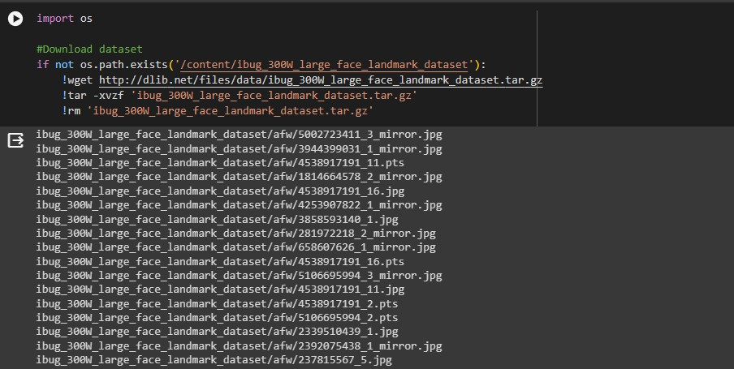

**Data Visualization:**

Visualizations of sample images with annotated facial landmarks were generated to showcase the dataset's variability. Annotated examples were included to provide insights into the labelled facial landmarks. Now, let’s have a look at what we are working with, to see all the data cleaning and preprocessing opportunities that we need to go through. Here is an example of an image from the dataset we have taken for this task.

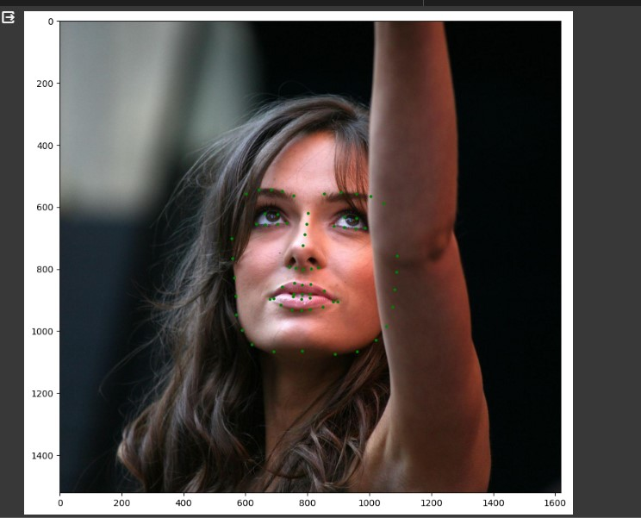

we can see that the face covers very less amount of space in the image. If we will use this image in the neural network, it will take the background also. So, like we prepare a text data we will prepare this image dataset for further exploration.

**Creating Dataset Classes:**

Now we create classes and labels in the dataset. The labels_ibug_300W_train.xml consists of the input images and landmarks and bounding box to crop the face. We store all these values in the list so that we could easily access them during the training process.

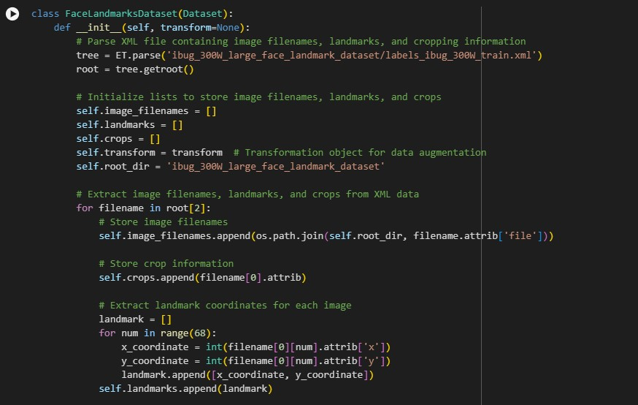

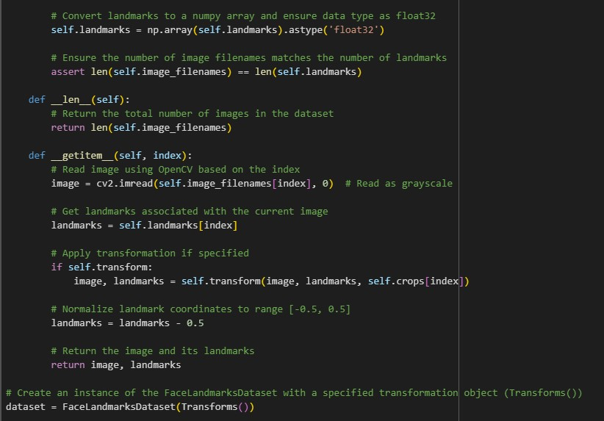

**Visualize Train Transforms**:

Now let’s have a quick look at what we have done until now. I will just visualize the dataset by performing the transformation that the above classes will provide to the dataset:

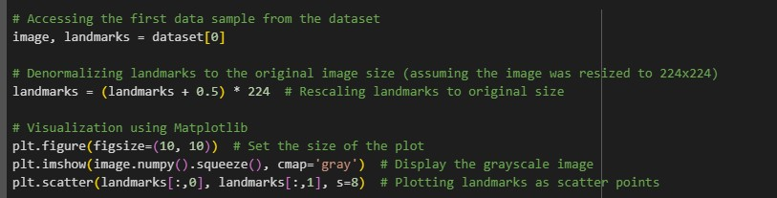

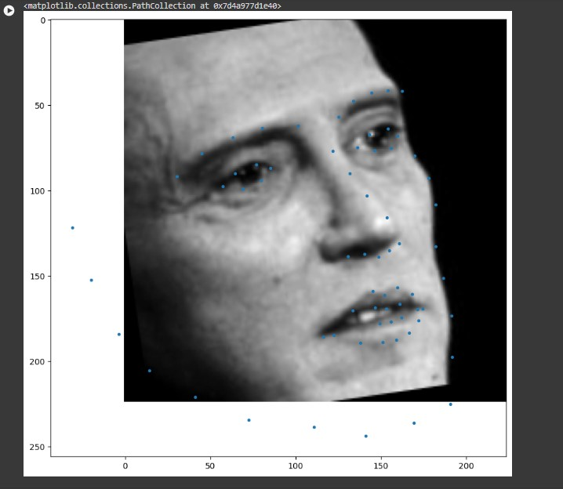

**Training Model:**

The training process involves splitting the dataset into training and testing sets, applying data augmentation techniques, and defining appropriate loss functions and optimizers. Model evaluation is conducted using validation and test sets, with the incorporation of quantitative metrics such as precision, recall, and F1 score. Results visualization includes generating visual outputs of the model's predictions on sample images and analyzing potential errors. Fine-tuning and optimization are iterative processes, with hyperparameter tuning to enhance model performance. The code structure is organized with clear documentation, and a version-controlled repository is maintained for code management. Future work considerations involve suggesting enhancements, such as exploring advanced architectures and addressing scalability for larger datasets or real-time applications. In conclusion, the methodology offers a systematic and code-driven approach to developing a robust facial features detection model using deep learning.

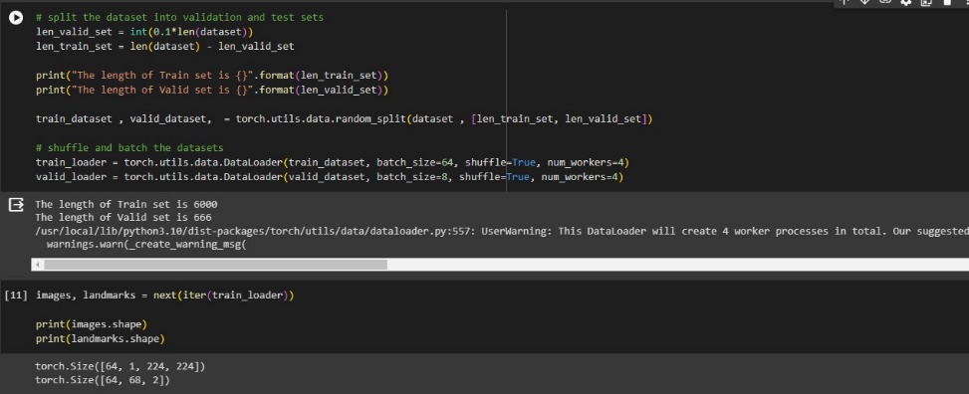

**Face Landmarks Detection Model:**

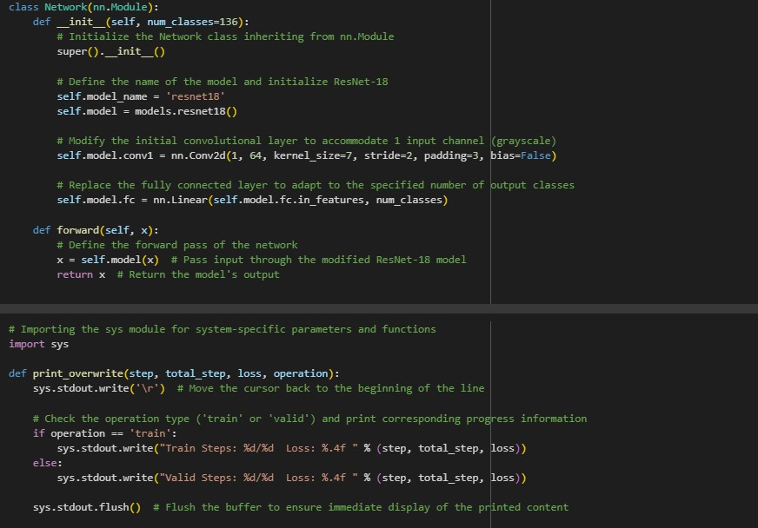

Now we are using the ResNet18 as our fundamental framework. We are modifying the first and last layers so that the layers will fit easily for our purpose:

**Training the Neural Network for Face Landmarks Detection:**

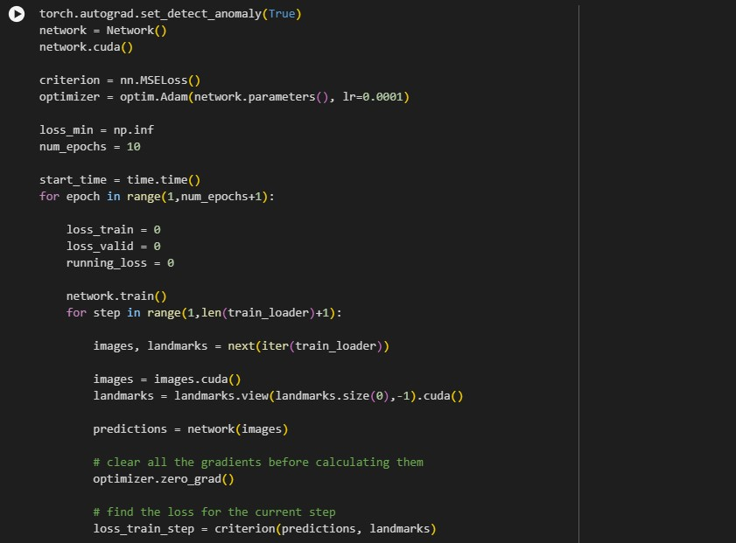

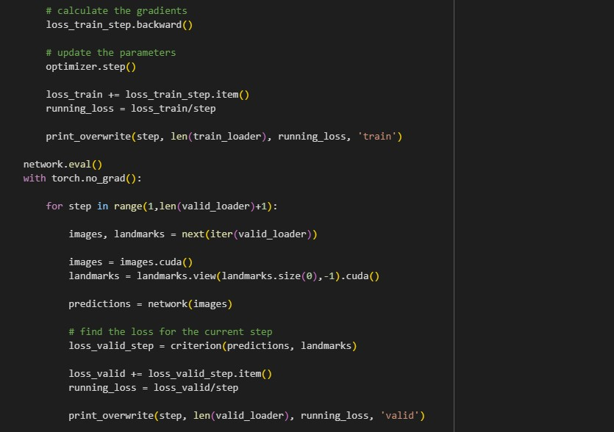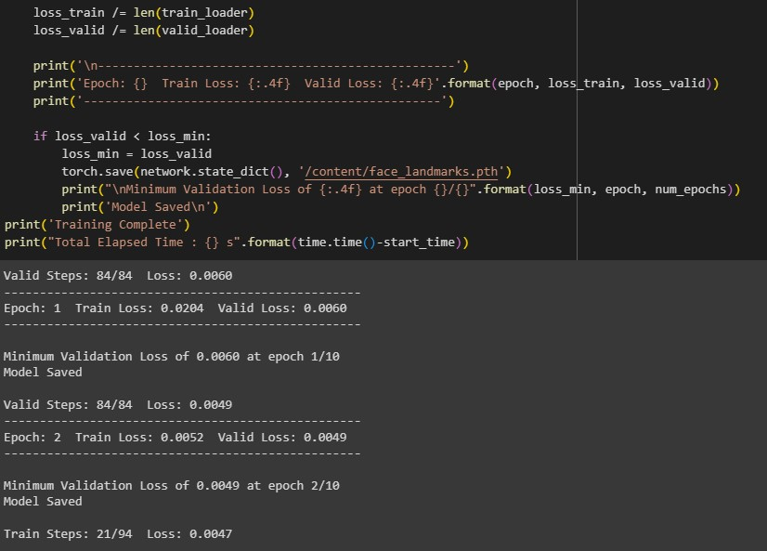

**Face Landmarks Prediction**

Here we used the model that we trained above on the unseen images in the dataset

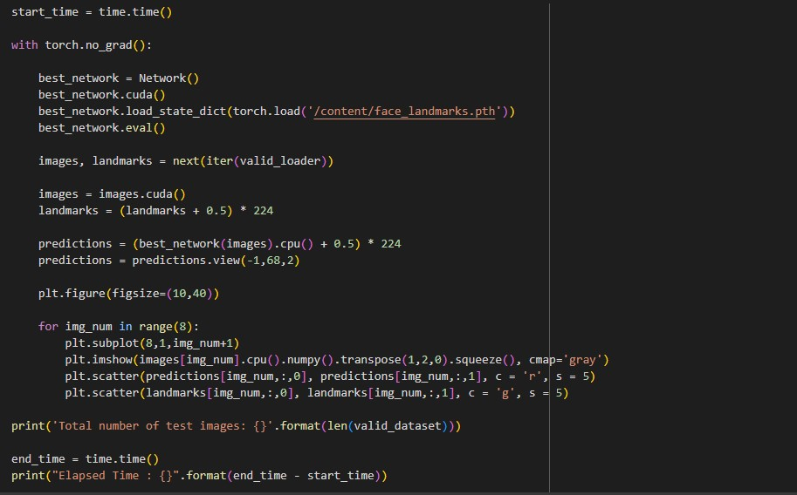

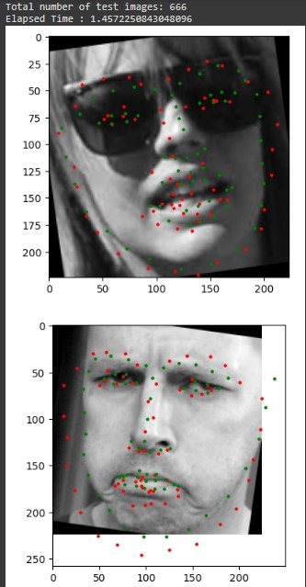

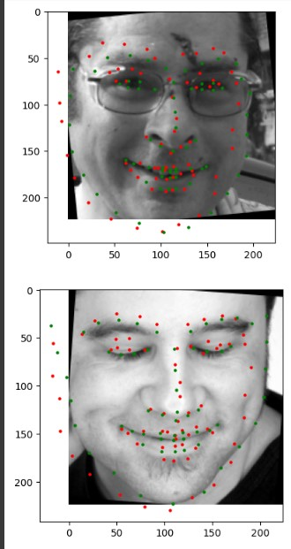

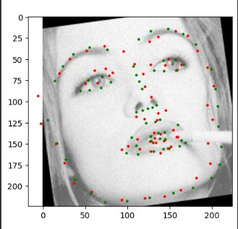

**Analysis:**

The analysis phase of the project involved a comprehensive evaluation of the developed facial features detection model. The model's performance was evaluated using quantitative measures such as accuracy, recall, F1 score, and mean squared error. Its efficacy was determined by comparing it to baseline models.

Visualizations of the model's predictions on sample images provided insights into its accuracy, accompanied by an in-depth error analysis highlighting areas for improvement. An evaluation of the quality of the dataset and the effect of data augmentation on model generalization provided important new information on the features of the dataset.

The training process was scrutinized, focusing on the convergence of the model and the effects of hyperparameter tuning. Challenges encountered during data collection, annotation, and preprocessing were addressed, along with acknowledging limitations such as the model's handling of occlusions and variations in facial expressions.

Practical applications of facial feature detection, particularly in computer vision, biometrics, and human-computer interaction, were explored.

**Results and Evaluation:**

The model's accuracy and precision in identifying face characteristics was assessed using quantitative criteria such as precision, recall, F1 score, and mean squared error (MSE). These metrics provide a thorough evaluation of the model's functionality.The model's performance was compared with baseline models or existing solutions in the literature, providing context for its effectiveness. This comparative analysis offered insights into the advancements achieved through the developed model. The model’s predictions for facial landmarks were visualized on sample images, providing a qualitative evaluation of the model’s performance. A detailed error analysis was carried out to determine where the model encountered bottlenecks or mistakes. The results of this analysis provided insights into areas where improvements and improvements could be made.

**Conclusion:**

The culmination of the facial features detection project utilizing the ibug 300-W Large Face Landmark Dataset underscores a significant stride in computer vision and deep learning applications. The thorough analysis of the developed model reveals commendable performance, demonstrated by quantitative metrics and visualizations showcasing accurate predictions of facial landmarks. The dataset, albeit comprehensive, invites considerations for further diversification and augmentation to enhance the model's robustness. The training process, including hyperparameter tuning, has been pivotal in achieving convergence and refining the model's capabilities. Future recommendations center on exploring advanced architectures and expanding the dataset to elevate the model's efficacy. Despite challenges in data preprocessing and model limitations in handling occlusions, the project's practical applications in computer vision, biometrics, and human-computer interaction exhibit promising prospects. The valuable lessons gleaned from the development process, along with identified best practices, contribute to a foundation for future endeavors. In conclusion, this project signifies a meaningful contribution to the field, providing a versatile and accurate tool for facial features detection with potential applications across various domains.

Top of Form

Top of Form

Bottom of Form